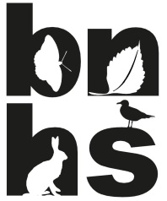
Bedfordshire Natural History Society
Registered Charity No: 268659

Theed-Pearse Award

The Theed-Pearse Award is an annual award made to organisations to recognise their work in a particular project that supports the aims of the Bedfordshire Natural History Society (BNHS).

By assisting financially with projects, the Theed-Pearse Award aims to further the objectives of the BNHS. In particular, it aims to further the objective set out in Rule 2(c) of the Society's Rules, "The Society shall do all that it can to protect the fauna and flora of the county and shall collaborate with other bodies in the conservation of areas of particular natural history interest".

Procedure
- BNHS Scientific Committee and Council will be invited to consider and nominate potential recipients of the Award
- A short note of the project that the award will support should be made available to aid discussion
- Any recommendations will be considered at the December meeting of BNHS Council where one award can be approved for payment in the following financial year

Guidelines
- Awards will only be made to organisations operating in Bedfordshire, and for a project based in Bedfordshire
- The project should serve to meet the aims and objectives of the BNHS by involving some aspect of monitoring, recording or conservation in Bedfordshire
- The priority for the award is to support small-scale projects
- One award of up to £500 can be made each year, subject to a suitable project being identified, and to sufficient monies being in the BNHS funds
- Acknowledgement of the receipt of the award by the organisation is required for auditing purposes
- A brief report in one of the Society’s publications should highlight the organisation that has received a Theed-Pearse Award, and the project for which it was awarded
- The BNHS does not accept any liability for any injury or loss resulting from equipment purchased or works carried out as part of the project

Revised : December 2017

